**Android Sensor Programing**

**By: Savan Yeshwanth Rao**

**CSUid: 2784780**

**Add a UI control on the screen of the second activity so that you can close the second activity and go back to the first activity (i.e., the main activity). In addition, on the main activity, display an iteration count that reflects the number of times the main activity has been displayed on the front ground.**

* At beginning after the opening the new project for usingintent and creating the 2nd java class as discussed in the class and following the pdf till creating a second activity.java and activity_second.xml.

To add an UI control screen in the second activity so that we can close the 2nd activity and go back to main, as we can see below how to add the **button** added to the **activity_second.xml**

<**Button  
 android:id="@+id/button"  
 android:layout_width="wrap_content"  
 android:layout_height="wrap_content"  
 android:layout_alignParentStart="true"  
 android:layout_marginStart="77dp"  
 android:layout_marginTop="310dp"   
 android:layout_marginEnd="77dp"s  
 android:layout_marginBottom="300dp"  
 android:background="@color/black"  
 android:backgroundTint="#03A9F4"** //background tint to blue  **android:onClick="onClick"  
 android:text="GoBACK"** //Button name **tools:ignore="HardcodedText,MissingConstraints,OnClick"** /> //to ignore all the hardcode text such as button name. (optional)

* Now for the “**GOBACK**” button to work, I have initialed the 2nd activity in Androidmanifest.xml for the parent class as **android:parentActivityName= “.MainActivity” (**Lets the activity know which activity to return when back is pressed when more than 2 activities are working**)** so when we debug, the 2nd activity “**onClick”** to finish since we have used “**finish();”** and the task which is non and on “**GOBACK**” button is pressed it would return to the parent class i.e., the MainActivity.java.

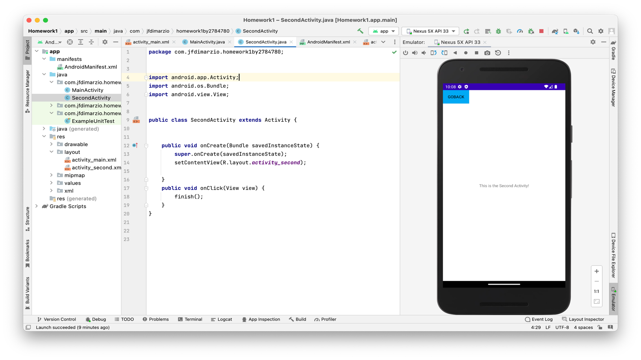

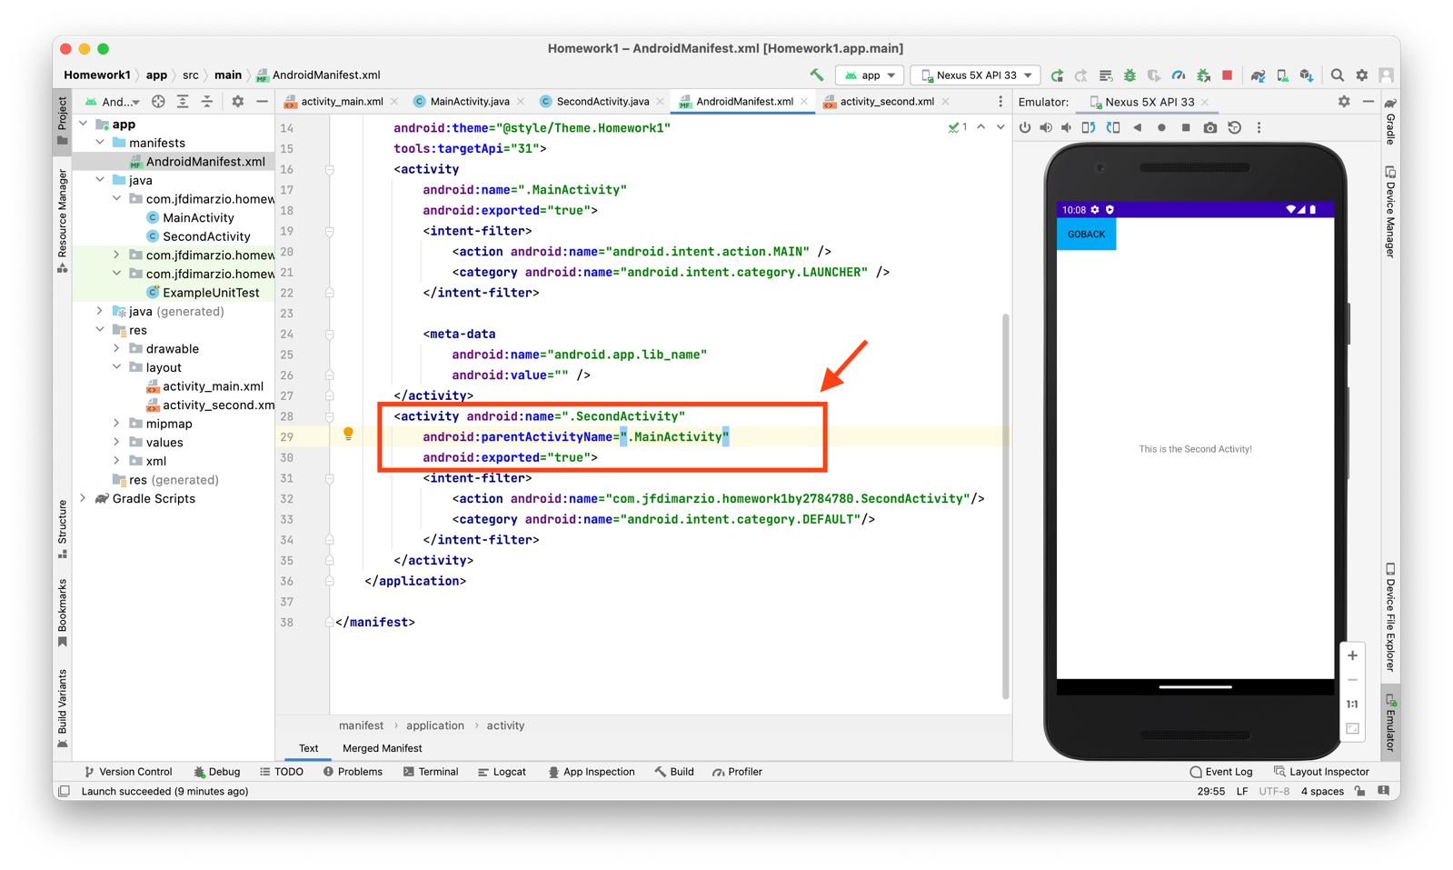

* Now to count the number of times we have come back to the MainActivity.java from SecondActivity.java, 1st I have created the “**count**” banner using “TextView” in **activity_main.xml,** and id “**countback**” to detect the TextView in the mainactivity.java.

<**TextView  
 android:layout_width="wrap_content"  
 android:layout_height="wrap_content"  
 android:layout_gravity="center"  
 android:layout_marginStart="8dp"  
 android:layout_marginTop="52dp"  
 android:layout_marginEnd="352dp"  
 android:layout_marginBottom="641dp"  
 android:text="Count" //text name as “count” to count the iteration  
 android:id="@+id/countback" //using id name as “countback” to detect the TextView.  
 android:textSize="30sp"  
 app:layout_constraintBottom_toBottomOf="parent"  
 app:layout_constraintEnd_toEndOf="parent"  
 app:layout_constraintHorizontal_bias="0.0"  
 app:layout_constraintStart_toStartOf="parent"  
 app:layout_constraintTop_toBottomOf="@+id/textView"  
 app:layout_constraintVertical_bias="0.333"  
 tools:ignore="HardcodedText"** />

* Now initially the count is kept to **‘1’** as global value since we have not yet went to second activity and came back to the 1st activity, and used a “**TextView back**” using which we can call the countback id in the below “**onRestart”** function, so every time we go to second activity and come back (just like redoing our task) the count =1 will be displayed as shown the below figure and then the iteration of count starts when we keep going to second activity and coming back to main activity and the count is increment with “count = **+ count”**. Below I have provided the explanation of each line of the code.

**import** android.annotation.SuppressLint; // for @suppressLint  
**import** android.app.Activity;  
**import** android.content.Intent;  
**import** android.view.View;  
**import** android.os.Bundle;  
**import** android.widget.TextView;  
  
**public class** MainActivity **extends** Activity {  
 TextView **back**;  
 **int count** = 1 ;  
  
 @Override  
 **protected void** onCreate(Bundle savedInstanceState) {  
 **super**.onCreate(savedInstanceState);  
 setContentView(R.layout.***activity_main***);  
  
 }  
 **public void** onClick(View view) {  
 startActivity(**new** Intent(**"com.jfdimarzio.homework1by2784780.SecondActivity"**));  
  
 }  
 @SuppressLint(**"SetTextI18n"**) //to surpass the textI18n for setText  
 **public void** onRestart() {  
 **super**.onRestart();  
 **back** = findViewById(R.id.***countback***); //to find or call the view of TextView countback  
 **back**.setText(**"Count = "** + **count**);  
 **count**++;  
 }  
}

Below are the Screenshots of the code after debugging:

1: After debug phone screen. 2: Entering the Second Activity. 3: When pressed back 1st time.

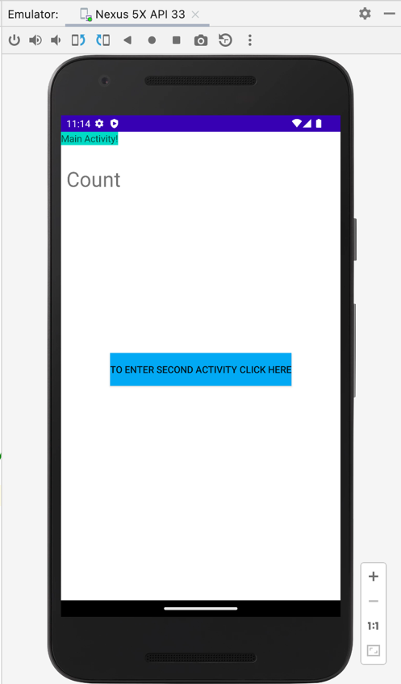 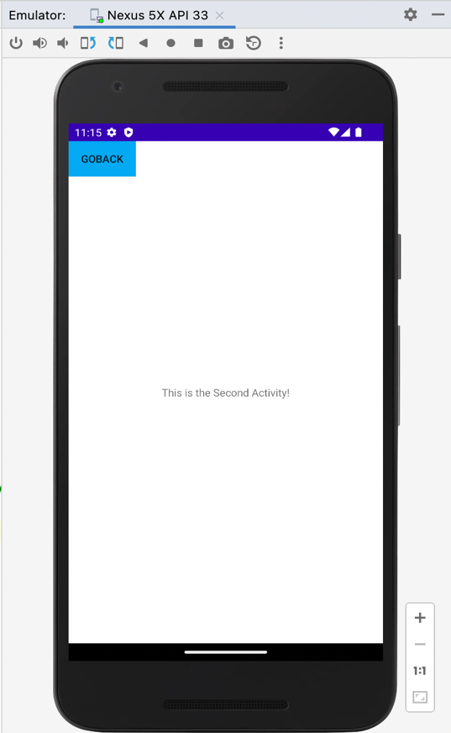 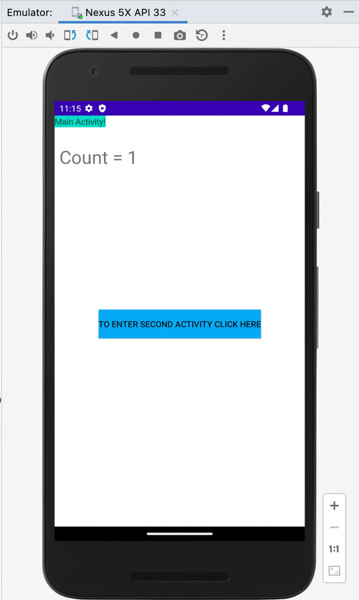

4: Back from 2nd activity 2nd time. 5: Back from 2nd activity 4th time. 6: Back from 2nd activity 7th time.

